HomeTasks:

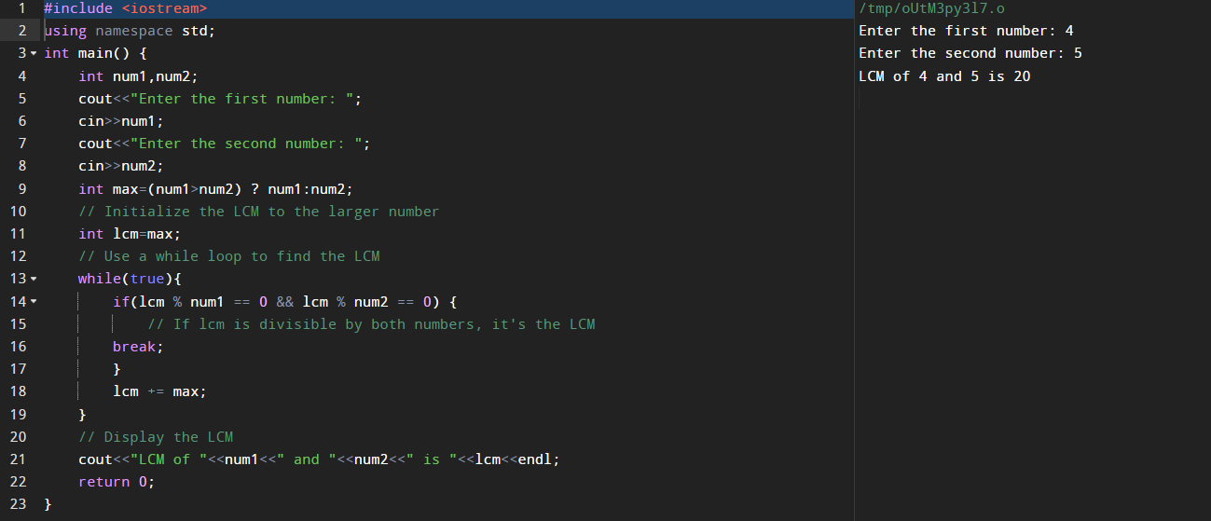1. Write a c++ program to find LCM of any two numbers using HCF.

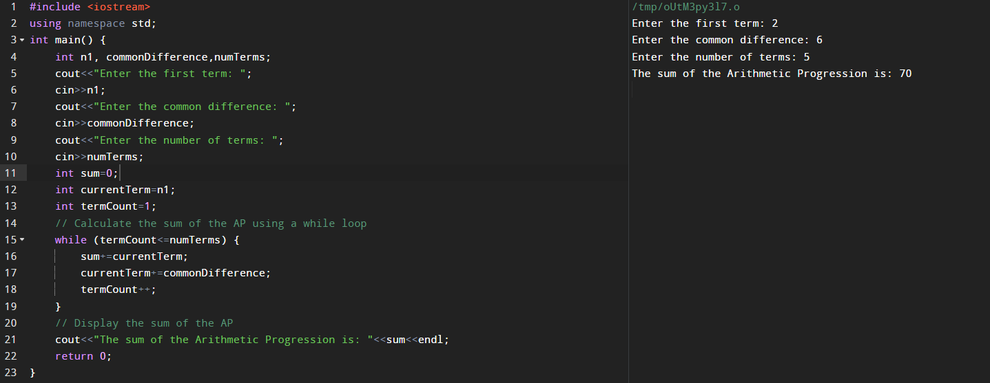2. Write a c++ program to find out the sum of arithmetic progression series.

3. Write a program to print a diamond.

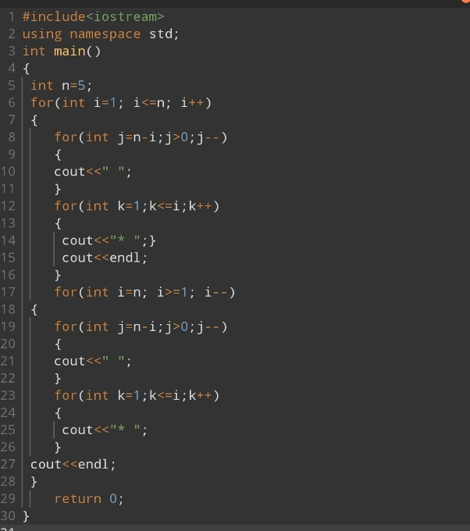

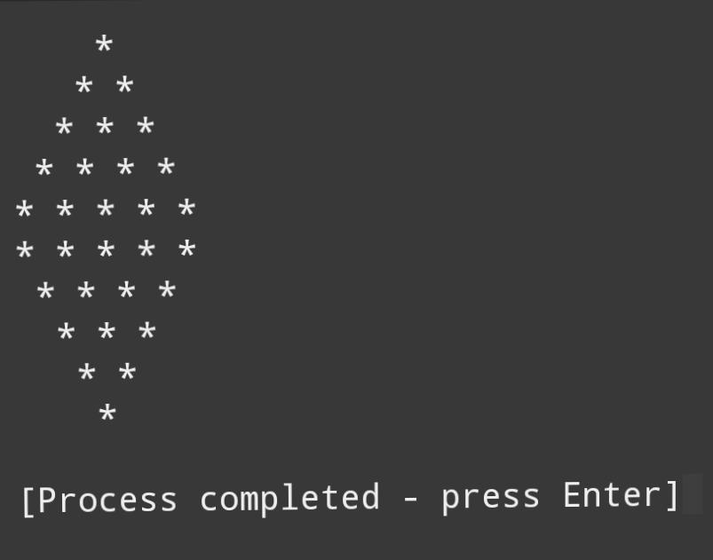

4. Write a c++ program to convert a decimal number into binary number.

